Task 1 – 1.1: Submit your screenshot showing the imported database and its tables. (5 points)

Upload File

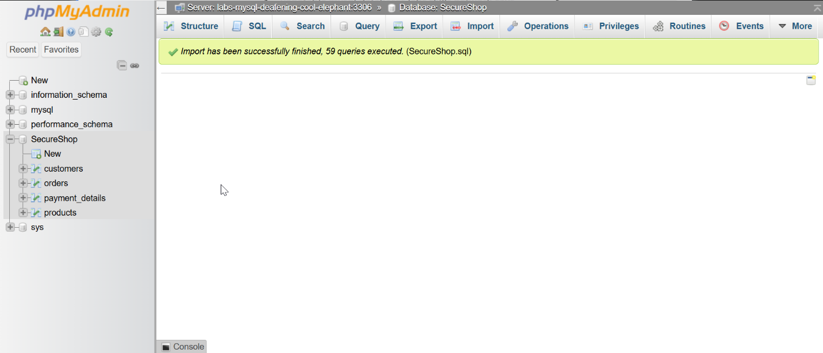

Task%201_1%20Upload%20the%20SQL.png

199KB

Upload completed

Title

​

Caption

​

Task 1 – 1.2.1: Submit the screenshot of the `payment_details` table. (1 point)

Upload File

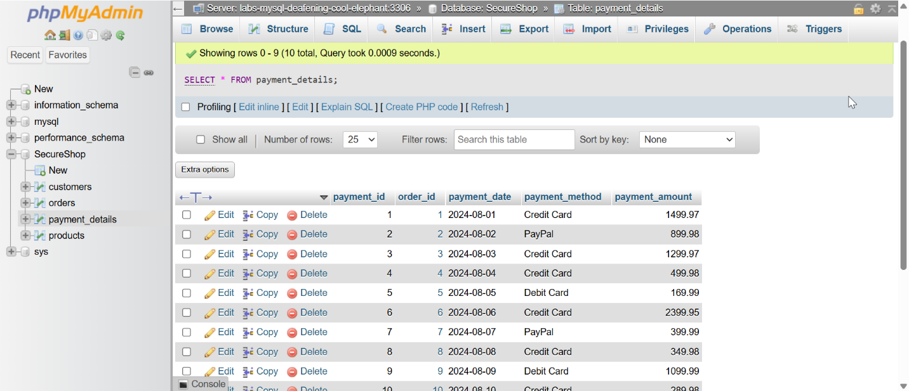

Task%201_2_1%20Payment%20Details.png

359KB

Upload completed

Title

​

Caption

​

Task 1 – 1.2.2: Submit the screenshot of the output after searching for all customers in the `customers` table. (1 point)

Upload File

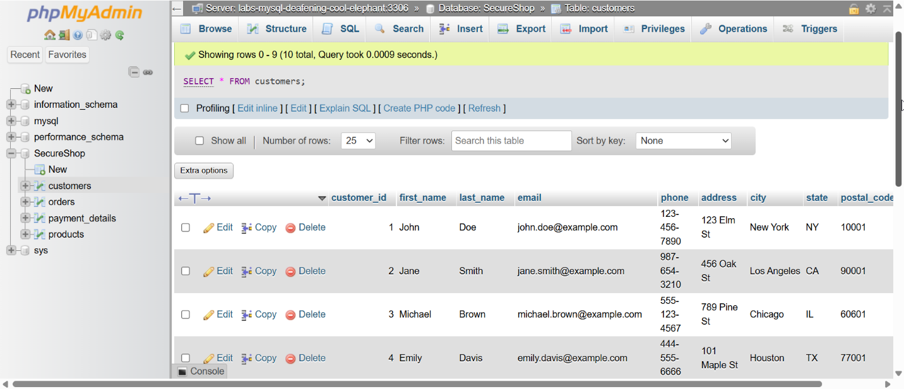

Task%201_2_2%20Customers.png

326KB

Upload completed

Title

​

Caption

​

Task 1 – 1.2.3: Submit the screenshot for the list of all products in the `products` table. (1 point)

Upload File

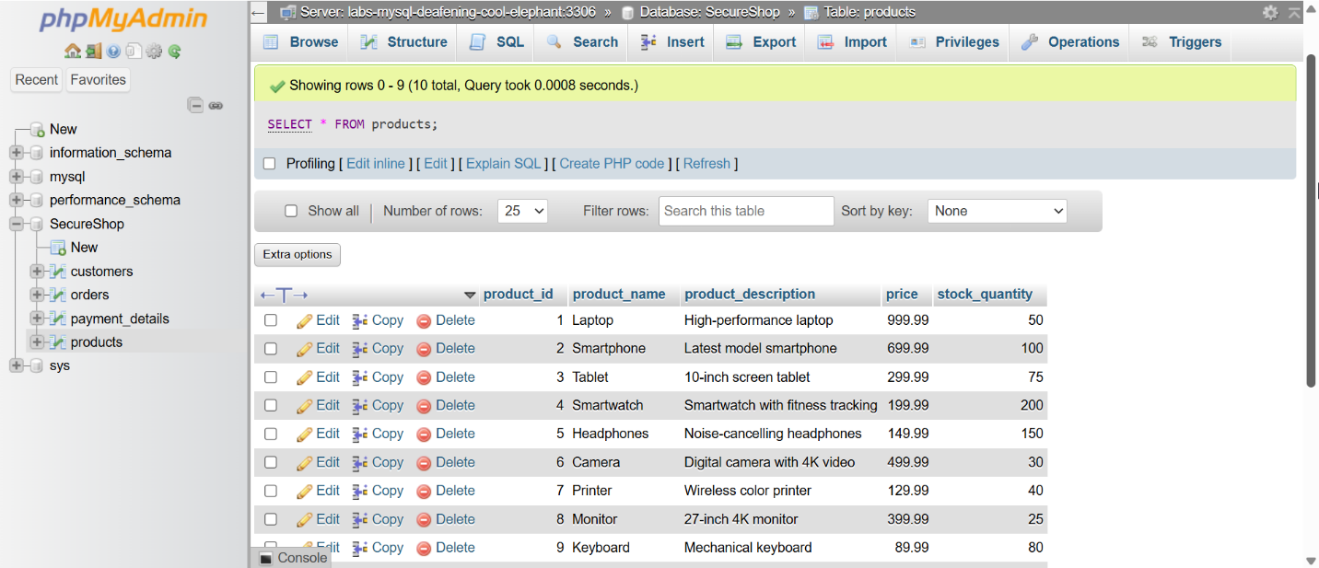

Task%201_2_3%20Products.png

357KB

Upload completed

Title

​

Caption

​

Task 1 – 1.2.4: Submit the screenshot of retrieved payment details for `order_id 7`. (1 point)

Upload File

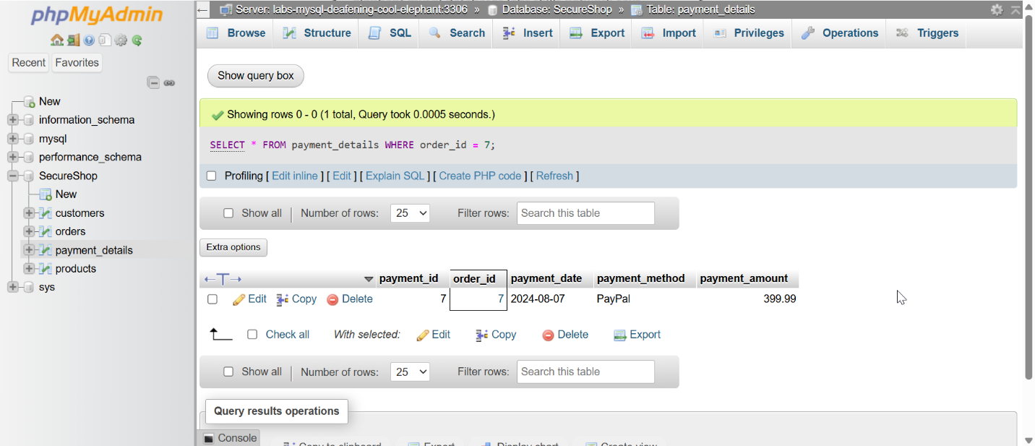

Task%201_2_4%20Orderid7.png

297KB

Upload completed

Title

​

Caption

​

Task 1 – 1.2.5: Submit the screenshot of orders placed by the customer named `David`. (1 point)

Upload File

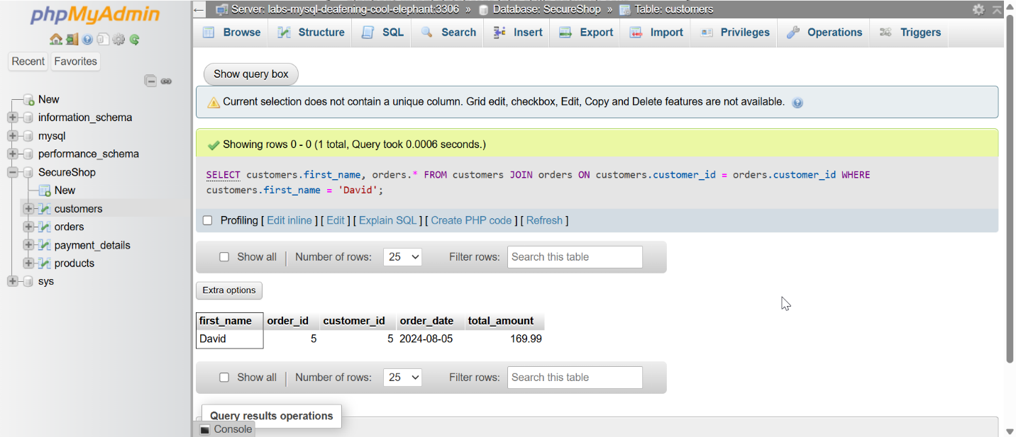

Task%201_2_5%20David2.png

296KB

Upload completed

Title

​

Caption

​

Task 2 – 2.1.1: Submit the screenshot showing the encrypted phone number of customers. (3 points)

Upload File

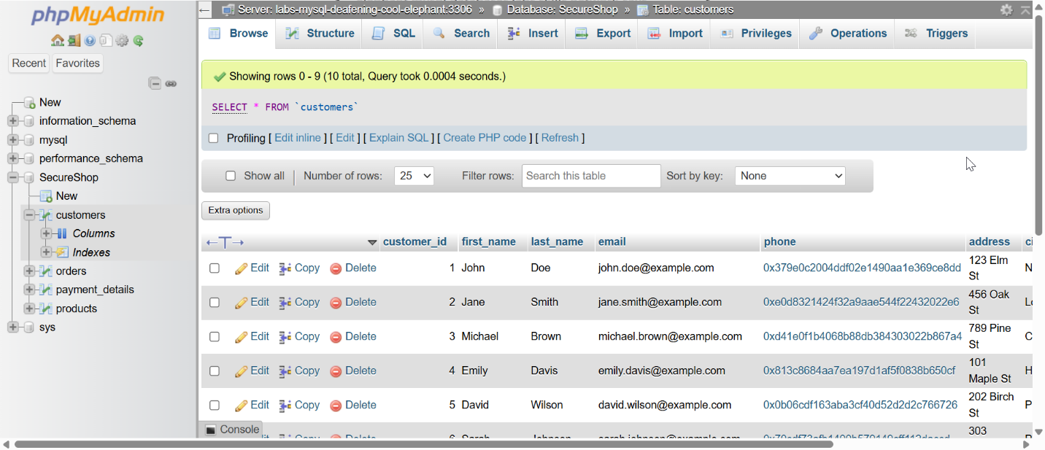

Task%202_1%20Phone%20no%20Encrypted.png

346KB

Upload completed

Title

​

Caption

​

Task 2 – 2.1.2: Submit the screenshot showing the decrypted phone number of customers. (3 points)

Upload File

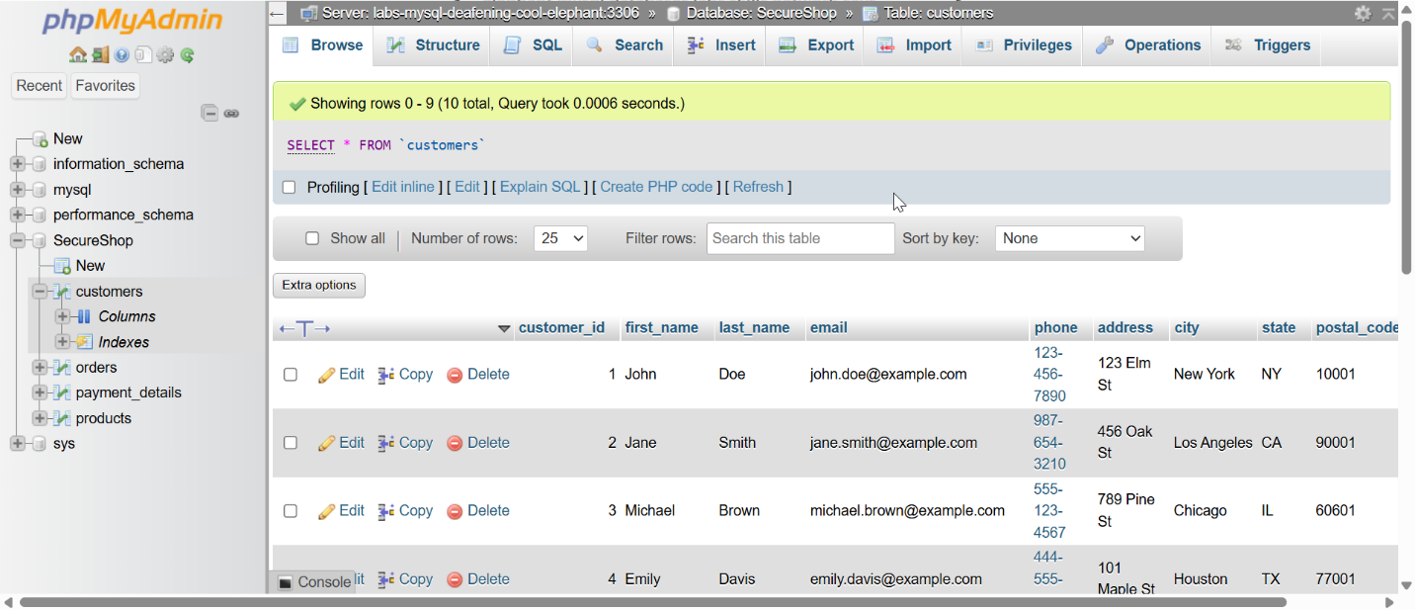

Task%202_2%20Phone%20no%20Decrypted.png

321KB

Upload completed

Title

​

Caption

​

Task 2 – 2.2: Submit the screenshot with masked data, showing only the last two digits of a customer's postal code. (4 points)

Upload File

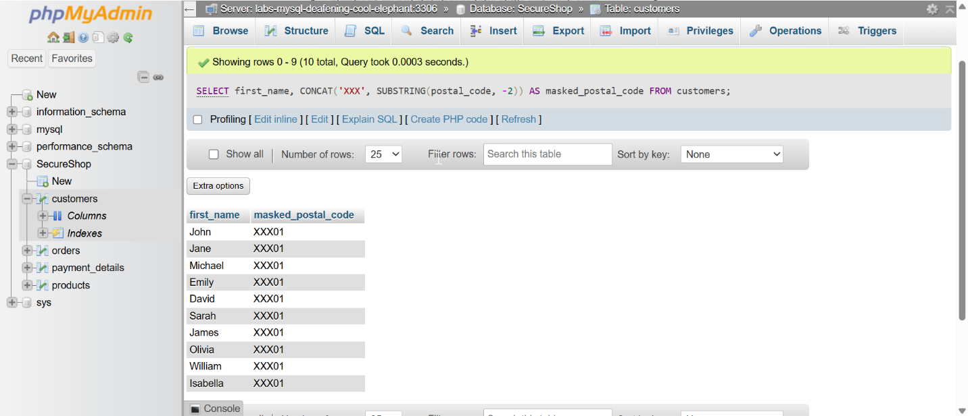

Task%202_3%20Masked%20Postal%20Code.png

278KB

Upload completed

Title

​

Caption

​

Task 3 – 3.1.1: Submit a screenshot of the results showing the creation of the user "Delivery Executive". (2 points)

Upload File

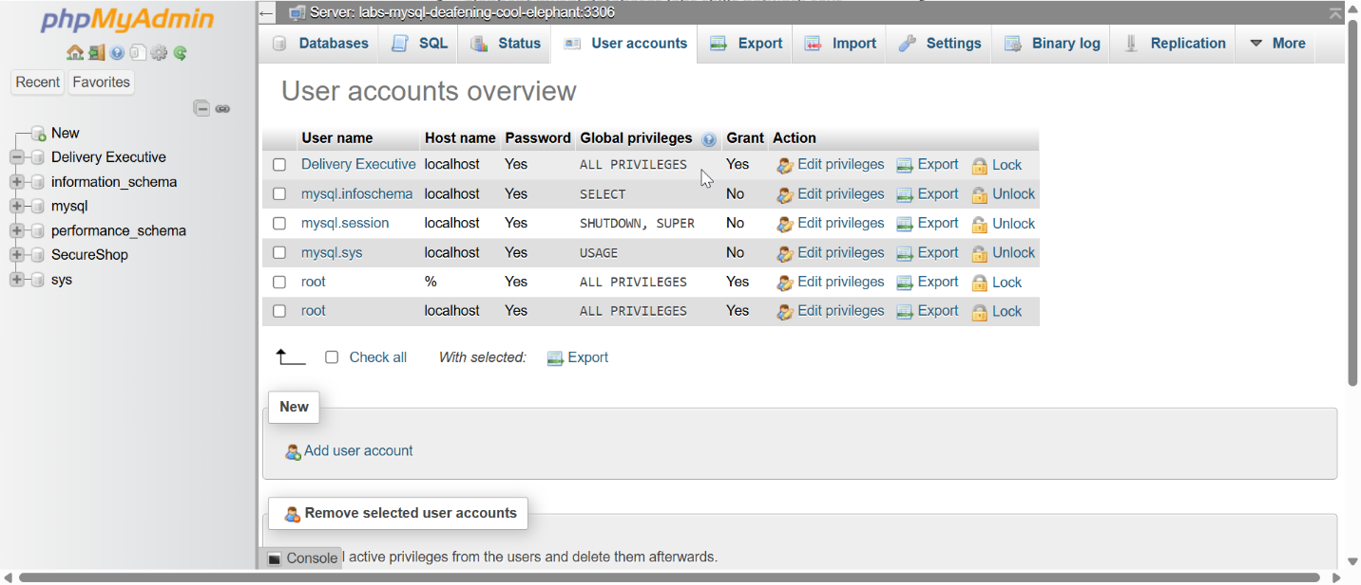

Task%203_1%20Delivery%20Executive.png

332KB

Upload completed

Title

​

Caption

​

Task 3 – 3.1.2: Submit a screenshot after granting the "Delivery Executive" user the ability to SELECT, DELETE, and UPDATE records in the `customers` table. The screenshot should also show that you have verified the permission using "SHOW GRANTS". (4 points)

Upload File

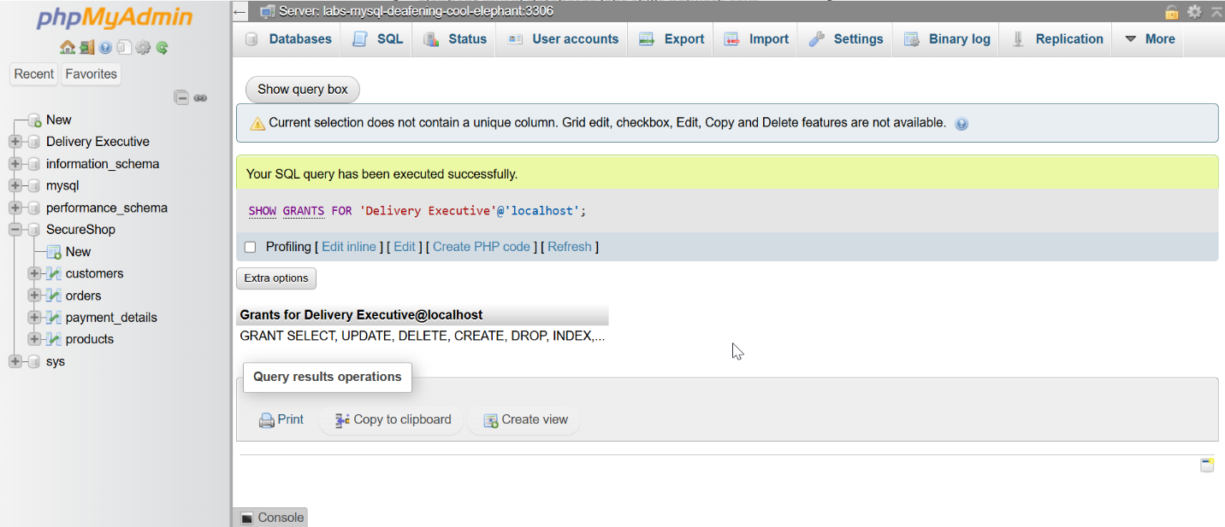

Task%203_1_2%20Checking%20Userpermission%20of%20Delivery%20Executive.png

276KB

Upload completed

Title

​

Caption

​

Task 3 – 3.1.3: Submit a screenshot after revoking the DELETE permission form "Delivery Executive" in the `customer` table and verifying the permission using "SHOW GRANTS". (4 points)

Upload File

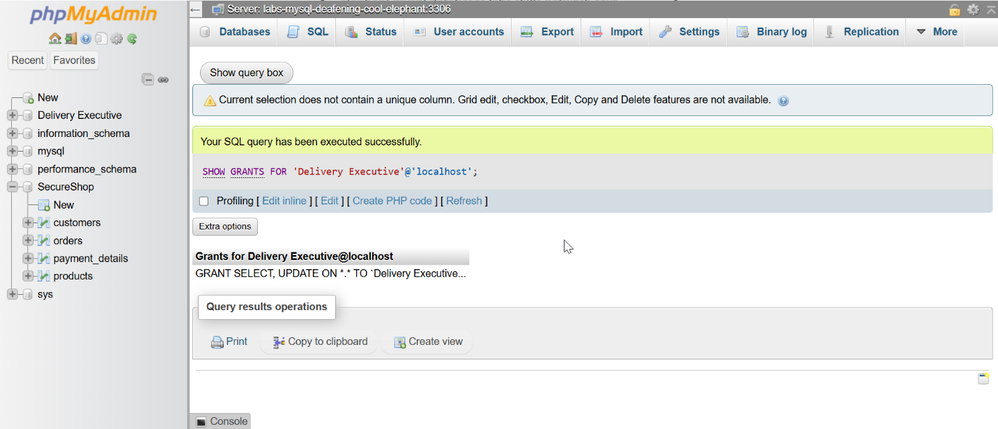

Task%203_1_3%20Revoke%20Delete%20permission%20of%20Delivery%20Executive.png

276KB

Upload completed

Title

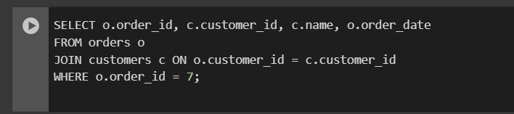

​

Caption

​

Task 4 – 4.1: Submit the screenshot of the output that retrieves customer information based on `order_id`. (10 points)